**LEARN DOCKER  
 by   
DOING**

**SC-1) Install DOcker-ce on Centos7.  
 Using devicemapper as storage device.**

1. **Removing old revisions.  
   yum remove docker \**

**> docker-client \**

**> docker-client-latest \**

**> docker-common \**

**> docker-latest \**

**> docker-latest-logrotate \**

**> docker-logrotate \**

**> docker-selinux \**

**> docker-engine-selinux \**

**> docker-engine**

1. **Install required packages for yum-config-manager and devicemapper storage driver**

**yum install -y yum-utils \**

**> device-mapper-persistent-data \**

**> lvm2**

1. **Add docker-ce repo   
     
   yum-config-manager --add-repo** [**https://download.docker.com/linux/centos/docker-ce.repo**](https://download.docker.com/linux/centos/docker-ce.repo)

**repo saved to /etc/yum.repos.d/docker-ce.repo**

1. **Install docker**

**yum install docker-ce  
# systemctl start docker**

**# systemctl enable docker**

1. **Creating user for docker   
     
   useradd dadmin   
   passwd dadmin  
   usermod –a –G docker dadmin**
2. **Test docker with hello-world  
   docker run hello-world**

**Sc-2) Changing storage Driver to overlay2**

1. **Disable SELINUX ] For Centos  
     
   # sestatus| grep status ] show the current status if selinux is**

**Enabled  
  
Edit /etc/selinux/config   
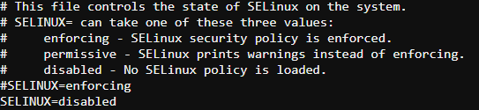**

**Reboot your system**

1. **Stop docker**systemctl stop docker
2. **If you are willing to save any of the old images , take backup of  
   /var/lib/docker**
3. **Edit /etc/docekr/daemon.json as   
     
   {**

**"storage-driver": "overlay2",**

**"storage-opts": [**

**"overlay2.override_kernel_check=true"**

**]**

**}**

**Storage-opts part is for Centos**

1. **Restart Docker**

**Sc-3) Changing logging Drivers :**

1. **Check current logging driver.**

# docker info | grep Logging

**Logging Driver: json-file**

1. **With json-file as logging driver we can check log with 🡪  
     
   docker logs <container_name>**
2. **Now changing logging driver to syslog.  
     
   - in /etc/rsyslog.conf   
   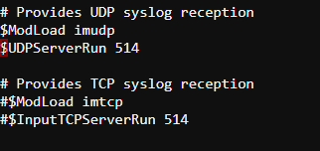  
     
   - restart syslog  
     
   systemctl restart rsyslog**
3. **Edit /etc/docker/daemon.json as 🡪**

**# cat daemon.json**

**{**

**"log-driver": "syslog",**

**"log-opts": {**

**"syslog-address": "udp://3.16.154.86:514"**

**}**

**}**

1. **Restart docker .**
2. **Now we are unable to check log with docker logs command   
   We need to check /var/log/messages**

**Sc-3.2) syslog to journal**[**https://docs.docker.com/config/containers/logging/journald/**](https://docs.docker.com/config/containers/logging/journald/)

**3.3) syslog to default json-log**

**/etc/docker/daemon.json**

**{**

**"log-driver": "json-file",**

**"log-opts": {**

**"max-size": "10m",**

**"max-file": "3"**

**}**

**}**

**Restart docker**

**3.4) setting up logging Driver on container run**

**# docker run \**

**> --log-driver json-file --log-opt max-size=10m \**

**> alpine echo hello world**

**Sc-4) Docker IMAGES:**

1. **Listing images using name and tag :**

**docker images 🡨 shows all images   
docker images java 🡨 shows all java images  
docker images java:7 🡨 shows java image with tag 7.  
  
format : docker images name:tag**

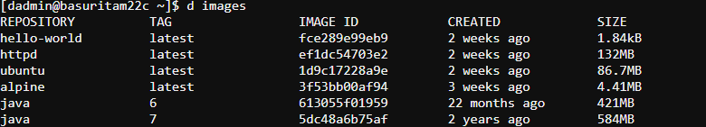

1. **Show image digests  
   Images that use the v2 or later format have a content-addressable identifier called a digest.  
     
   docker images --digests**



1. **To list full length image ID :**docker images --no-trunc
2. **Filtering Images :  
     
   show the dangling images:  
     
   This will display untagged images that are the leaves of the images tree (not intermediary layers). These images occur when a new build of an image takes the repo:tag away from the image ID, leaving it as <none>:<none> or untagged.  
     
   docker images –-filter “dangling=true”  
     
   show images created before Ubuntu:latest 🡪**d images --filter "before=Ubuntu”  
     
   **show images created after Ubuntu 🡪**  
     
   d images --filter "since=ubuntu"

**Filtering images with reference**docker images --filter=reference='jav*'  
  
**similar to 🡪**  
  
docker images jav*

1. **Delete the images which are dangling 🡪**  
     
   docker rmi $(docker images --filter "dangling=true" -q)   
    **-q is used to just show the shortened image ID :**
2. Show formatted O?P with

|  |  |
| --- | --- |
| .ID | Image ID |
| .Repository | Image repository |
| .Tag | Image tag |
| .Digest | Image digest |
| .CreatedSince | Elapsed time since the image was created |
| .CreatedAt | Time when the image was created |
| .Size | Image disk size |

docker images --format "{{.ID}}:\t{{.Repository}}\t{{.CreatedAt}}\t{{.Size}}"  
  
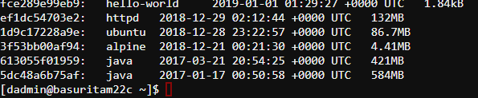

**O/P will be tab separated for \t**

**Sc-5) List the docker images of apache which are official and have stars more than 50.**  
  
docker search --filter stars=50 --filter is-official=true apache  
  
**NAME DESCRIPTION STARS OFFICIAL AUTOMATED  
  
we can filter by stars , is-official, is-automated.**  
  
**Sc-6) Tag your Ubuntu latest image as per repo/image_name:version_tag**

docker tag ubuntu:latest myrepo/myubuntu:v1  
  
**O/p:   
ubuntu latest 1d9c17228a9e 2 weeks ago 86.7MB**

**myrepo/myubuntu v1 1d9c17228a9e 2 weeks ago 86.7MB**

**you will notice the same ID.**

**SC-7) Delete the dangling images in a single command.  
 Try to delete all the images which are not associated with any container with the same command.**$ docker image prune  
  
$ docker image prune -a

**WARNING! This will remove all images without at least one container associated to them.**

**Are you sure you want to continue? [y/N] n**

**SC-8) Show the history of an image 🡪  
  
docker image history <image_name>**

**Sc-9) save a docker image as tar file,  
 Import it   
load it**docker image save -o my_ubuntu.tar ubuntu:latest  
  
docker image import my_ubuntu.tar **🡨 this will create a dangling image with repo:tag = <none>:<none>**docker image import my_ubuntu.tar my_ubuntu:v1 🡨 Correct   
 **my_ubuntu v1 465103b8cd84 21 seconds ago 89.2MB**docker image load --input my_ubuntu.tar  
  
**🡨 It will load the image with same name as it was used to be.  
  
Loaded image: ubuntu:latest**